A PROJECT REPORT



ON

LINE FOLLOWING ROBOT

## Department of Electrical &Electronics Engineering

Submitted by:

Aditi Kalkal

(1900910210004)

JSS ACADEMY OF TECHNICAL EDUCATION, NOIDA

CERTIFICATE

This is to certify that project on the topic

**LINE FOLLOWING ROBOT**

That has been successfully completed and submitted by

**Aditi Kalkal**

**(1900910210004)**

for the fulfillment of Summer Internship 2020

During the course of the project, they have worked sincerely and were good- throughout the implementation and presentation of the project undertaken

Dr. Sujatha K.S Pooja Prakash

(H.O.D EEE ) (Mentor)

***ABSTRACT***

The line following is a classic introductory robot design and requires- minimal amount of resources. This robot uses Microcontrollercontrol. This robot is intended to showcase basic sensor design and robot control systems in the form of a small autonomous robot that can follow a black line over a white surface.

A proposal for a line following robots and their relevance to engineering and society is given. A project design for a line following robot is presented and discussed. The project descriptions are given, as well as the project approach, experiments to be run, and a proposed schedule for completing the robot.

The vehicle is supposed to have low-resolution sensors and actuators. The control requirement, however, is specified to keep the vehicle as close as possible to the center of the line. The controllability issues are investigated, A multiple IR sensor-based control algorithm is investigated for straight as well as curved paths.

***Table of Contents***

Circuit Diagram

Components Required

Block Diagram of the Project

Block Diagram Description

Working of Arduino Line Follower Robot

Code (https://github.com/AditiKalkal/LFR/blob/main/code)

Applications of Line Follower Robot

Future work

Output Video (https://github.com/AditiKalkal/LFR/blob/main/Line%20Following%20robot%20Video.mp4)

***Circuit Diagram***

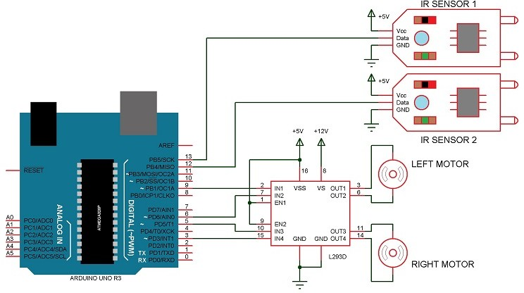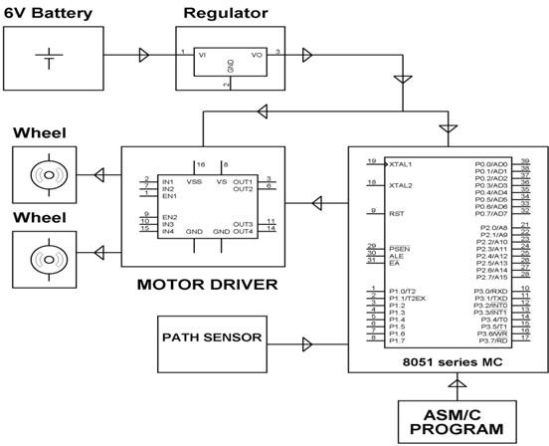

***Block Diagram of the Project***

The line follower robot built in this project is divided into 4 blocks. The following image shows the block diagram for the line follower robot.

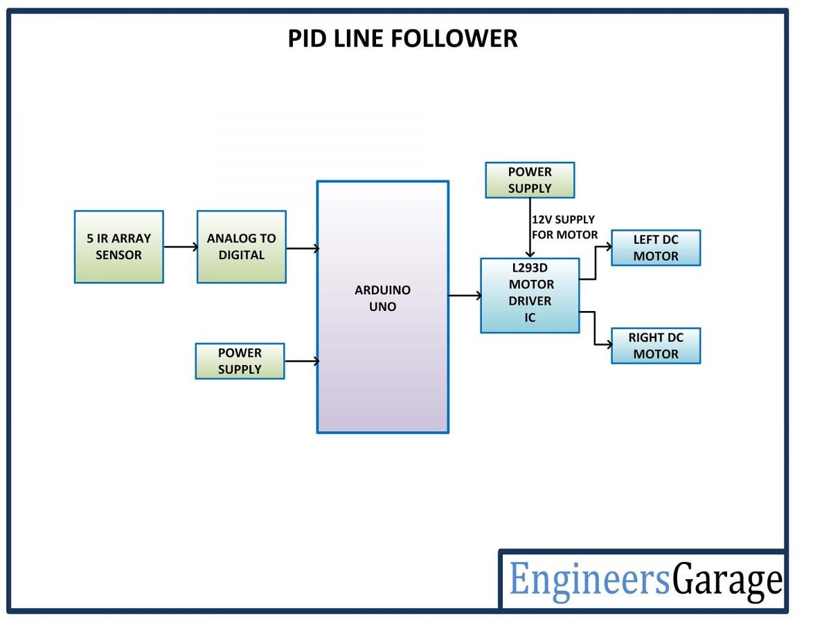

# Block Diagram Description

### Sensors (IR Sensor):

We have used IR Sensor Module as the line detecting sensor for the project. It consists of an IR LED and a Photodiode and some other components like comparator, LED, etc.

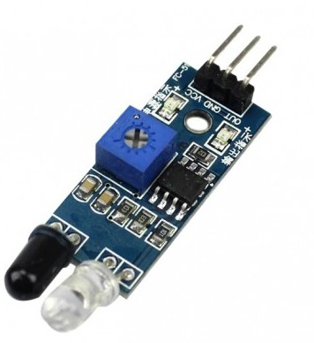

### Controller (Arduino UNO):

Arduino UNO is the main controller in the project. The data from the sensors (IR Sensors) will be given to Arduino and it gives corresponding signals to the Motor Driver IC.

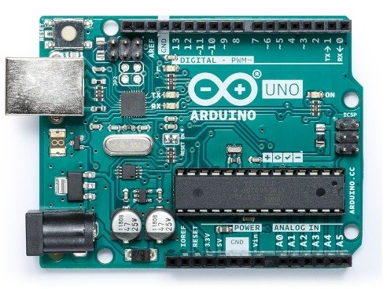

### Motor Driver (L293D):

L293D Motor Driver IC is used in this project to drive the motors of the robot. It - receives signals from Arduino based on the information from the IR Sensors.

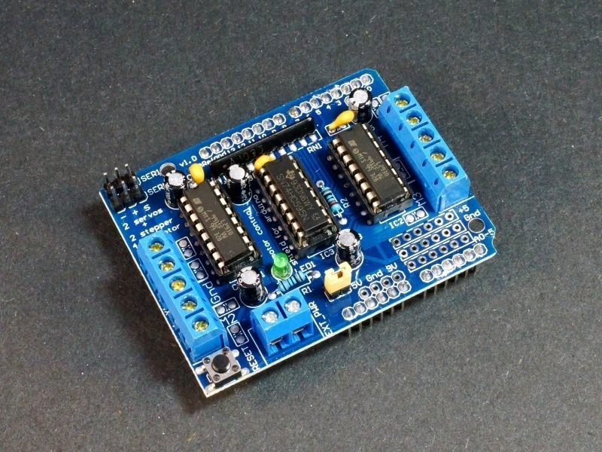

### Motors (Geared Motors):

We have used two geared motors at the rear of the line follower robot. These motors provide more torque than normal motors and can be used for carrying some load as well.

# Working of Arduino Line Follower Robot

In this project, we have designed an Arduino based Line Follower Robot. The working of the project is pretty simple: detect the black line on the surface and move along that line. The detailed working is explained here.

As mentioned in the block diagram, we need sensors to detect the line. For line detection logic, we used two IR Sensors, which consists of IR LED and Photodiode. They are placed in a reflective way i.e. side – by – side so that whenever they come into proximity of a reflective surface, the light emitted by IR LED will be detected by Photodiode.

The following image shows the working of a typical IR Sensor (IR LED – Photodiode pair) in front of a light-colored surface and a black surface. As the reflectance of the light-colored surface is high, the infrared light emitted by IR LED will be maximumly reflected and will be detected by the Photodiode.

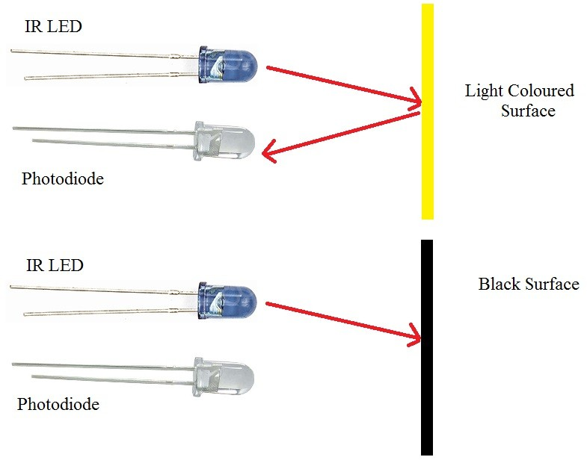

In the case of a black surface, which has a low reflectance, the light gets completely absorbed by the black surface and doesn’t reach the photodiode.

Using the same principle, we will set up the IR Sensors on the Line Follower Robot such that the two IR Sensors are on either side of the black line on the floor. The setup is shown below.

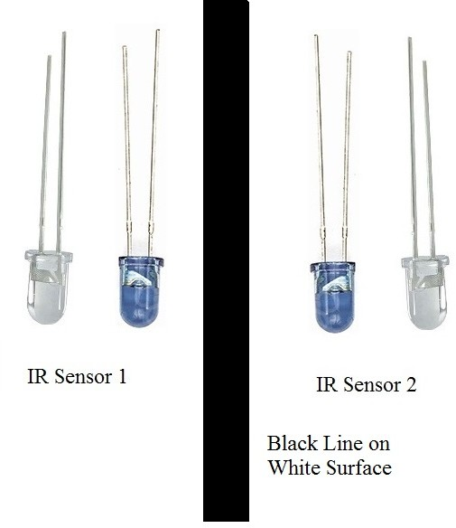

When the robot moves forward, both the sensors wait for the line to be detected. For example, if the IR Sensor 1 in the above image detects the black line, it means that there is a right curve (or turn) ahead.

Arduino UNO detects this change and sends a signal to the motor driver accordingly. In or- der to turn right, the motor on the right side of the robot is slowed down using PWM, while the motor on the left side is run at normal speed.

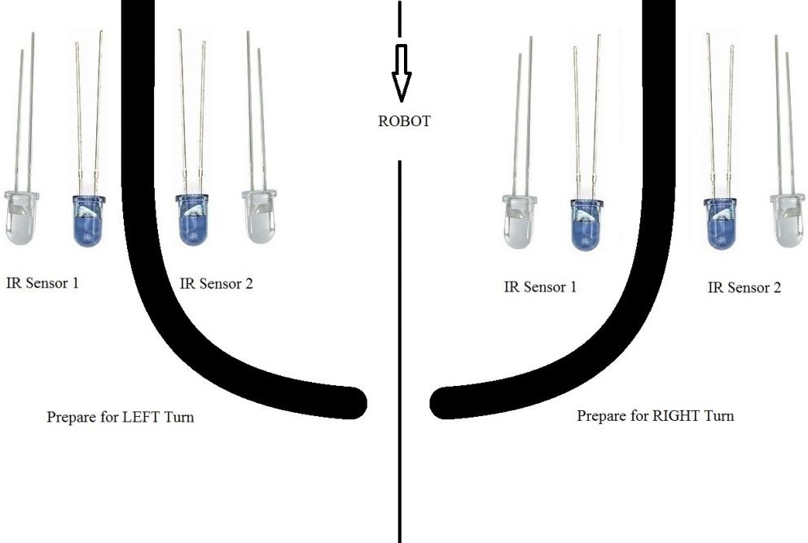

Similarly, when the IR Sensor 2 detects the black line first, it means that there is a left curve ahead and the robot has to turn left. For the robot to turn left, the motor on the left side of the robot is slowed down (or can be stopped completely or can be rotated in opposite direction) and the motor on the right side is run at normal speed.

Arduino UNO continuously monitors the data from both the sensors and turns the robot as per the line detected by them.

# CODE

int mot2=6;

int mot3=5;

int mot4=3; int mot1=9;

int left=13; int right=12;

int Left=0; int Right=0;

void LEFT (void); void RIGHT (void); void STOP (void);

void setup()

{

pinMode(mot1,OUTPUT); pinMode(mot2,OUTPUT); pinMode(mot3,OUTPUT); pinMode(mot4,OUTPUT);

pinMode(left,INPUT); pinMode(right,INPUT);

digitalWrite(left,HIGH); digitalWrite(right,HIGH);

}

void loop()

{

analogWrite(mot1,255); analogWrite(mot2,0); analogWrite(mot3,255); analogWrite(mot4,0);

while(1)

{

Left=digitalRead(left); Right=digitalRead(right);

if((Left==0 && Right==1)==1) LEFT();

else if((Right==0 && Left==1)==1) RIGHT();

}

}

void LEFT (void)

{

analogWrite(mot3,0); analogWrite(mot4,30);

while(Left==0)

{

Left=digitalRead(left); Right=digitalRead(right); if(Right==0)

{

int lprev=Left; int rprev=Right; STOP();

while(((lprev==Left)&&(rprev==Right))==1)

{

Left=digitalRead(left); Right=digitalRead(right);

}

}

analogWrite(mot1,255); analogWrite(mot2,0);

}

analogWrite(mot3,255);

analogWrite(mot4,0);

}

void RIGHT (void)

{

analogWrite(mot1,0); analogWrite(mot2,30);

while(Right==0)

{

Left=digitalRead(left); Right=digitalRead(right); if(Left==0)

{

int lprev=Left; int rprev=Right; STOP();

while(((lprev==Left)&&(rprev==Right))==1)

{

Left=digitalRead(left); Right=digitalRead(right);

}

}

analogWrite(mot3,255); analogWrite(mot4,0);

}

analogWrite(mot1,255);

analogWrite(mot2,0);

}

void STOP (void)

{

analogWrite(mot1,0); analogWrite(mot2,0); analogWrite(mot3,0); analogWrite(mot4,0);

}

# Applications of Line Follower Robot

Line follower Robots are commonly used for the automation process in industries, military applications, and consumer applications.

They are very useful as they can work without any supervision i.e. they work as automatic guided vehicles.

With additional features like obstacle avoidance and other security measures, line follower robots can be used in driverless cars.

# Limitations of Line Follower Robot



Line follower robot requires 2-3 inches broad line.

It may not move properly if the black line drawn is of low intensity

The IR sensors may sometimes absorb IR rays from surroundings also. As a result, robots may move improperly.

# Future Work

In the process of development of the line follower, most of the useful feature is identified and many of them were implemented. But due to the time limitations and other factors, some of these cannot be added. So the development features in brief: · Use of

the color sensor. · Use of CCD camera for better recognition and precise tracking of the path.

Output Video (https://github.com/AditiKalkal/LFR/blob/main/Line%20Following%20robot%20Video.mp4)